1. Unprotected admin functionality 1
2. Unprotected admin functionality with unpredictable URL 2
3. User role controlled by request parameter 3
4. User role can be modified in user profile 4
5. URL-based access control can be circumvented 5
6. Method-based access control can be circumvented 5
7. User ID controlled by request parameter 7
8. User ID controlled by request parameter, with unpredictable user IDs 8
9. User ID controlled by request parameter with data leakage in redirect 10
10. User ID controlled by request parameter with password disclosure 10
11. Insecure direct object references 11
12. User ID controlled by request parameter with password disclosure 12
13. Multi-step process with no access control on one step 13
14. Referer-based access control 13

Unprotected admin functionality
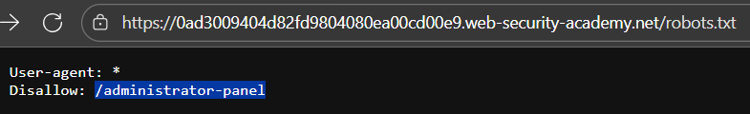
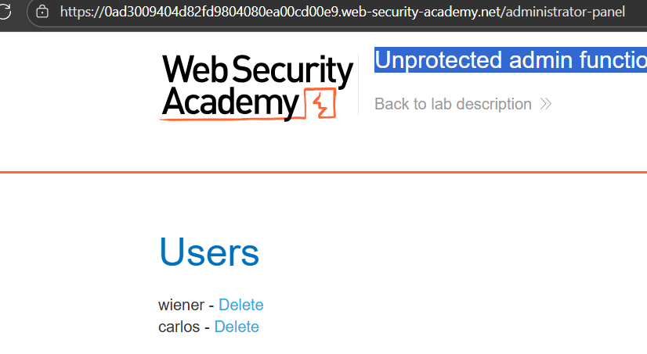

Unprotected admin functionality with unpredictable URL
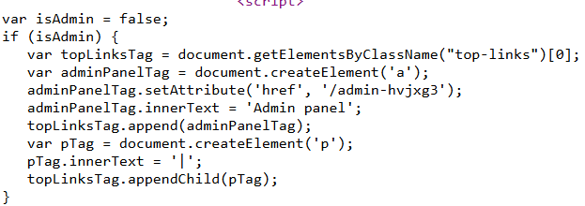
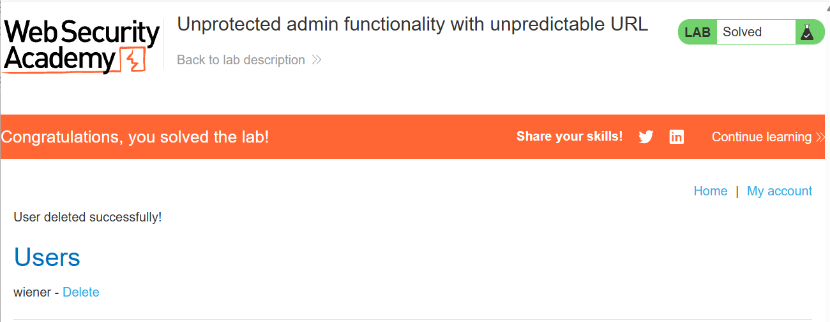

User role controlled by request parameter
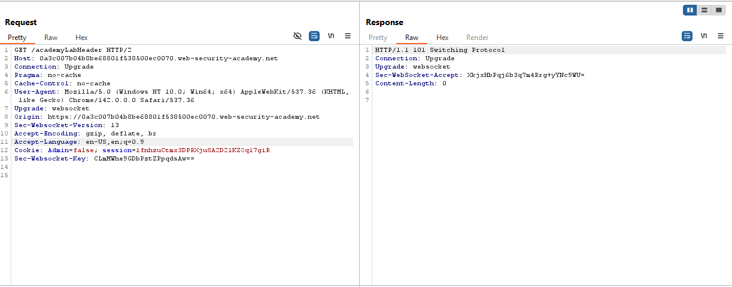
Intercept cookie: true
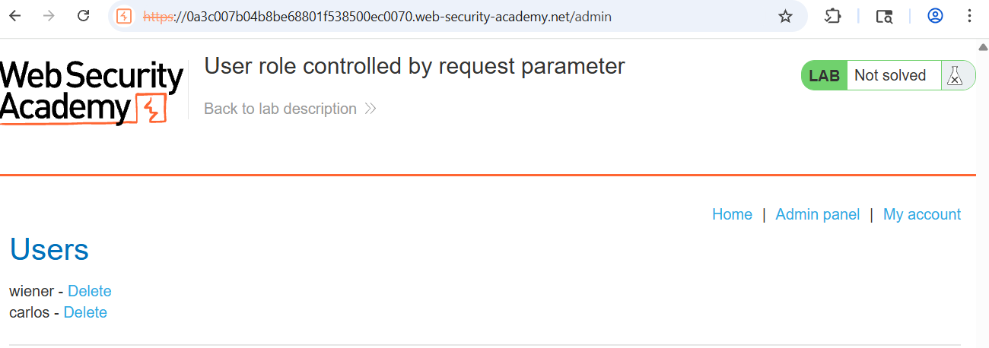
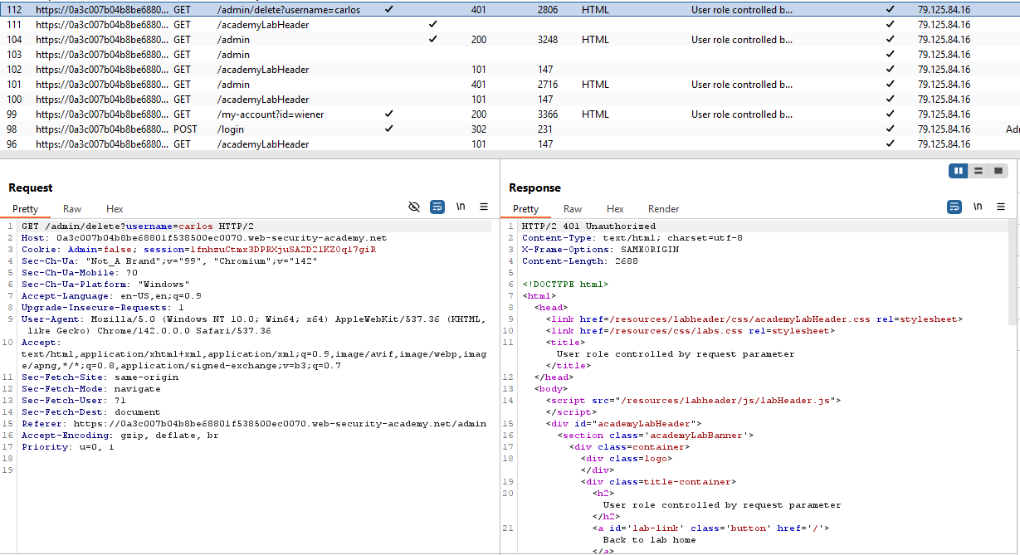

User role can be modified in user profile
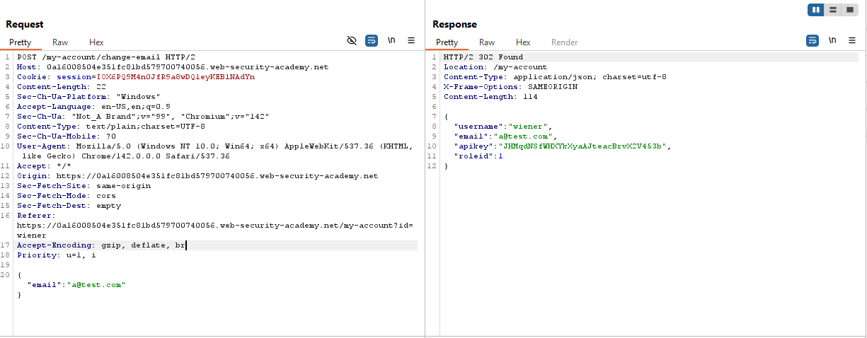
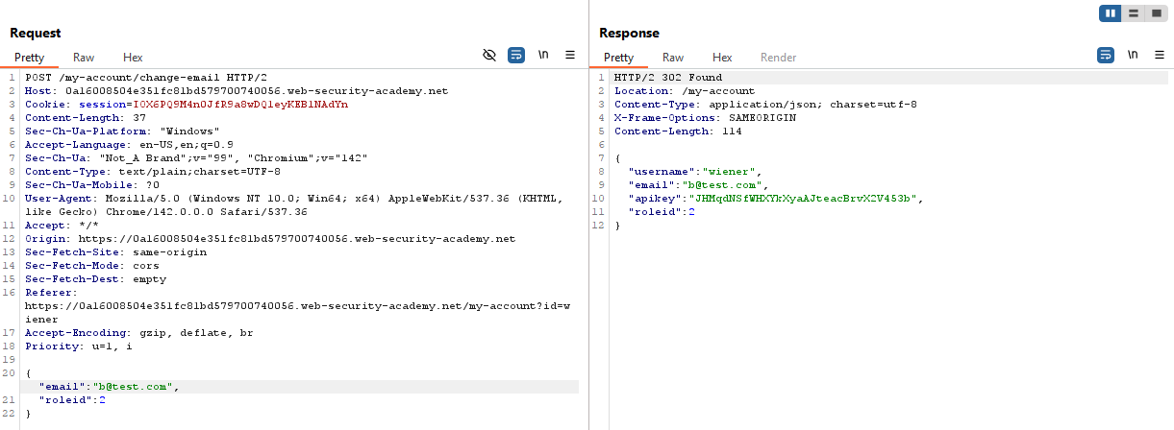

URL-based access control can be circumvented
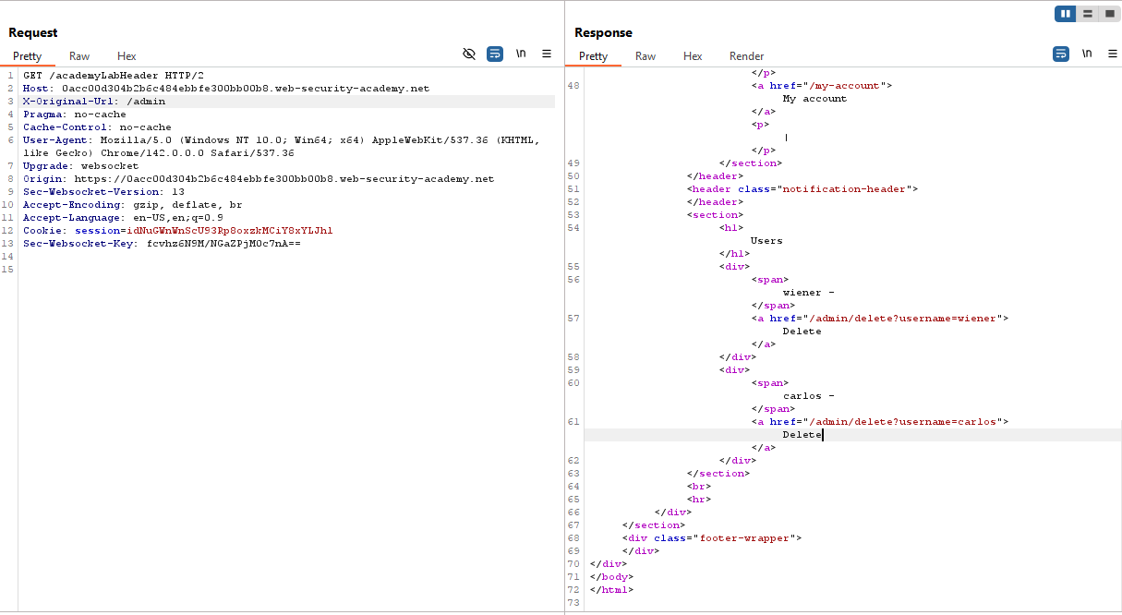
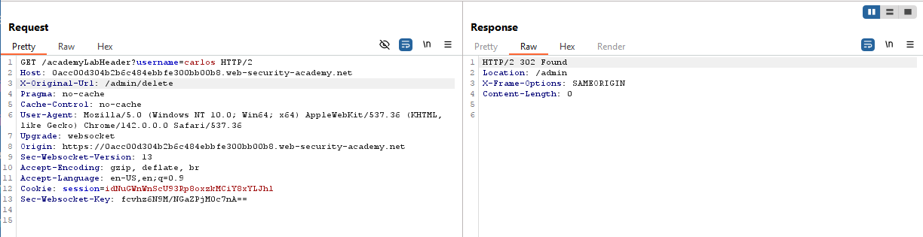

Method-based access control can be circumvented
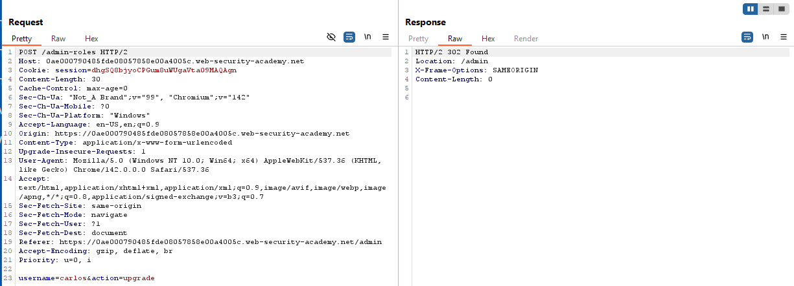
Đăng nhập vào tk không được cấp quyền trên trình duyệt ẩn danh
Và sử dụng session của tk không được cấp quyền
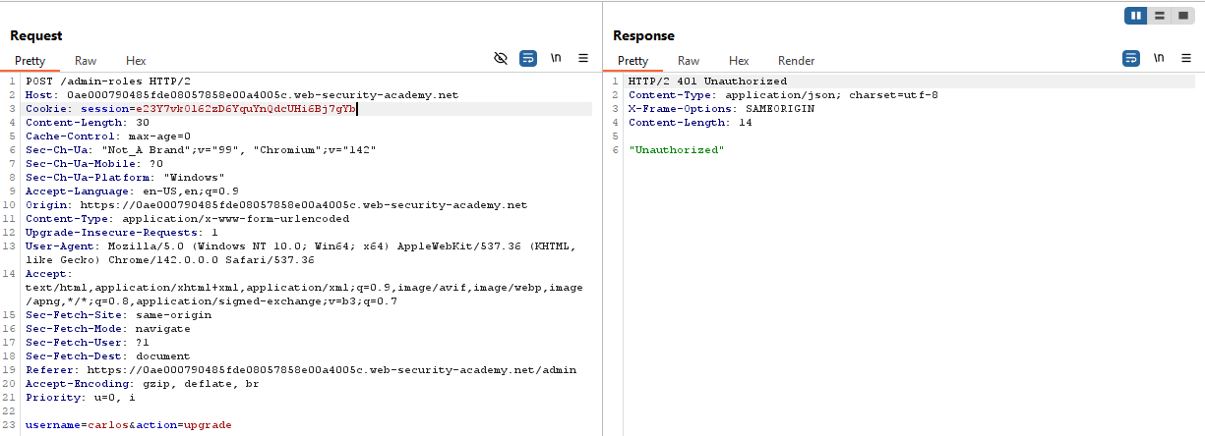
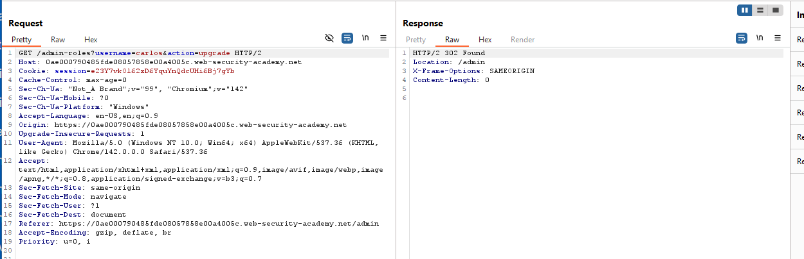
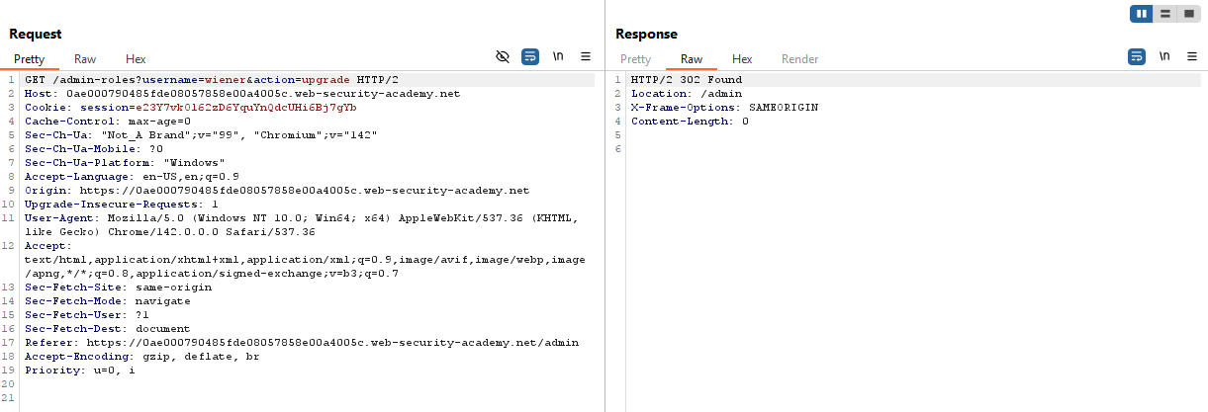

User ID controlled by request parameter
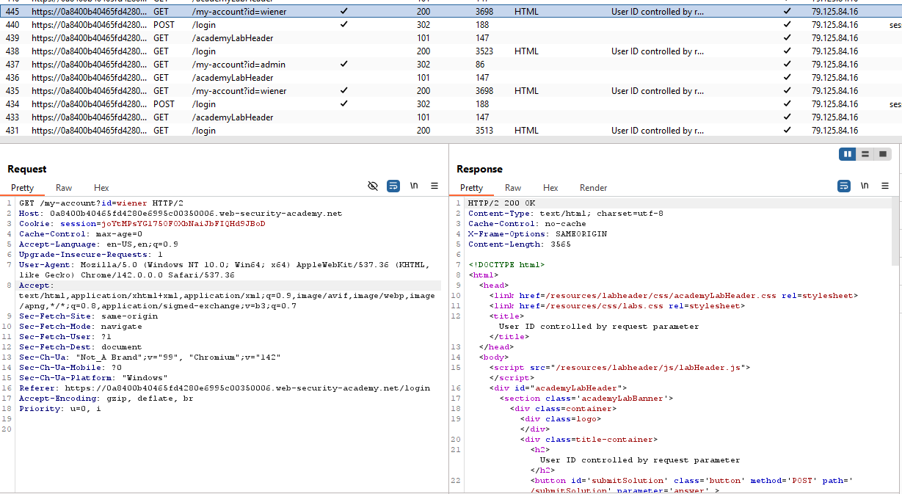
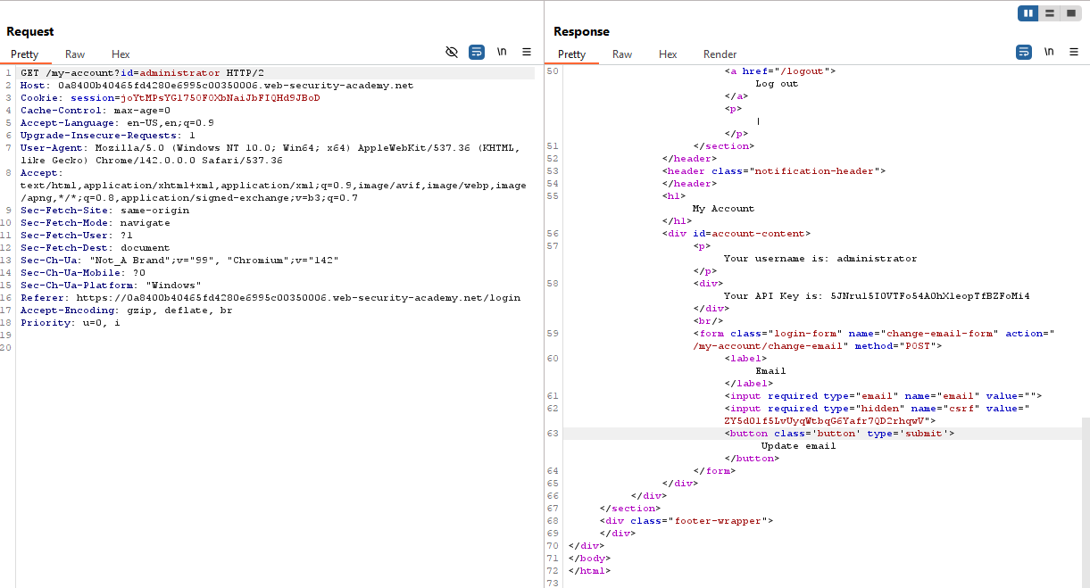

User ID controlled by request parameter, with unpredictable user IDs
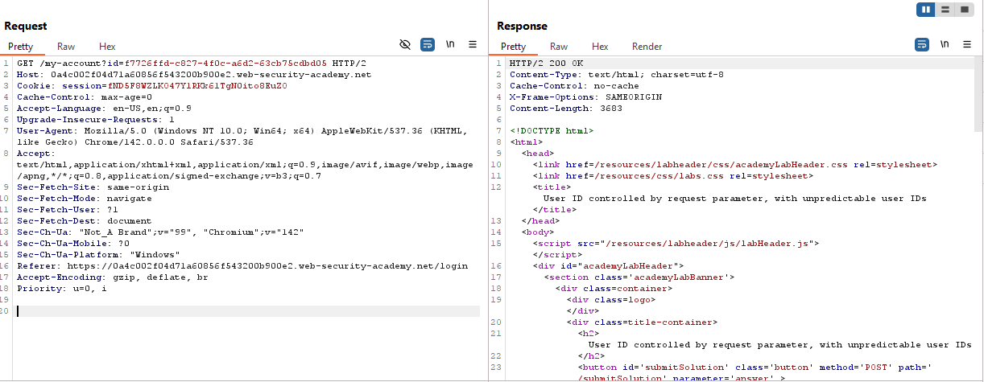

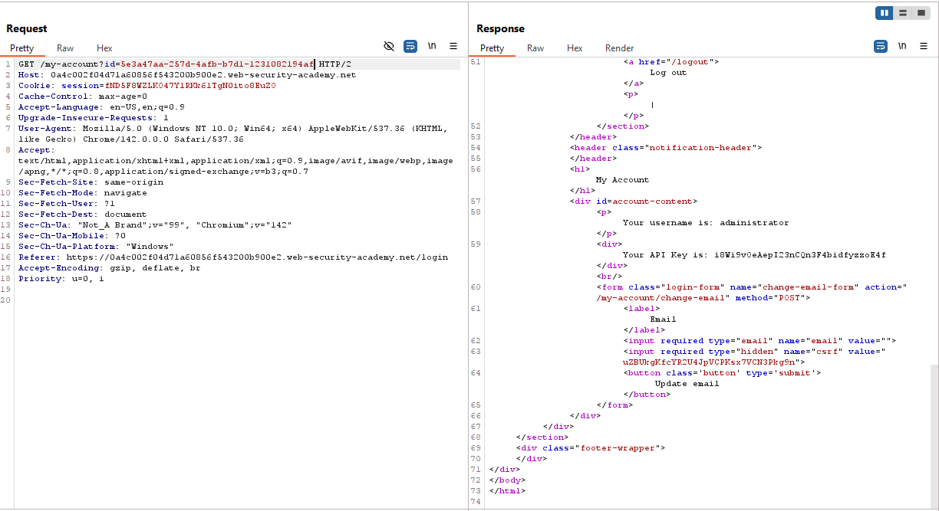

User ID controlled by request parameter with data leakage in redirect
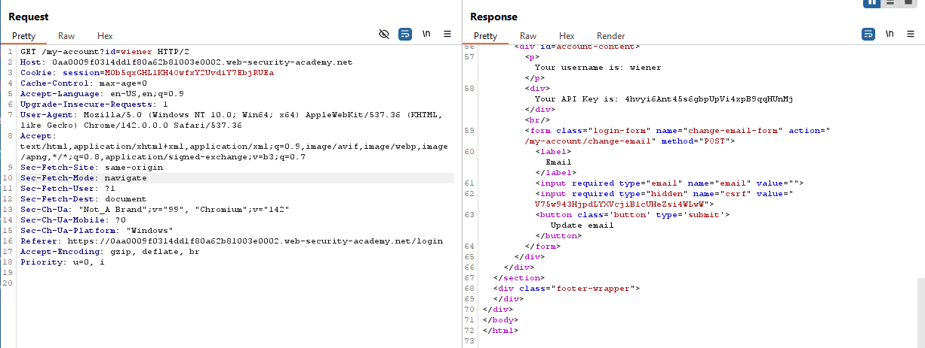
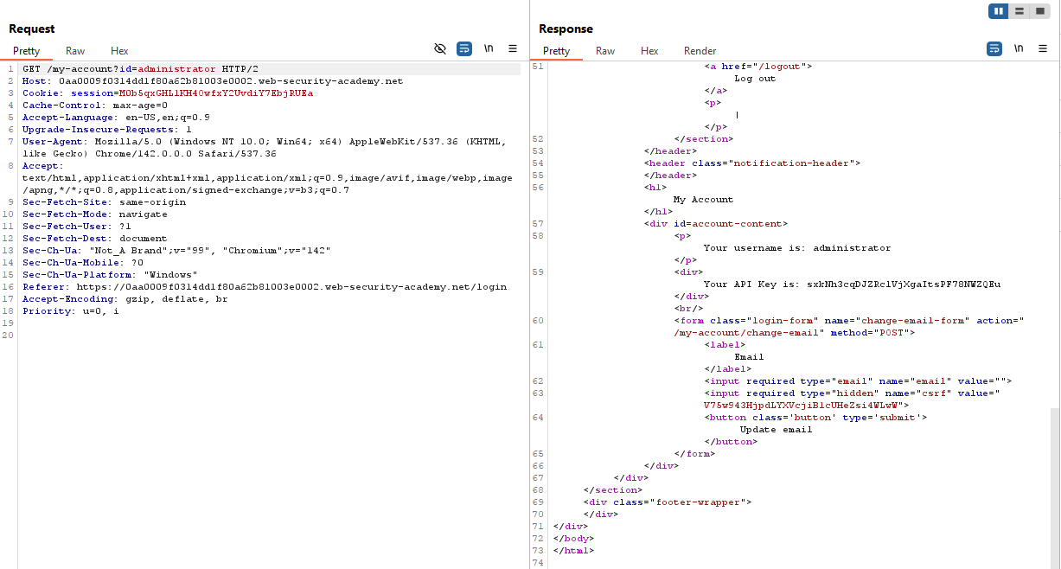

User ID controlled by request parameter with password disclosure
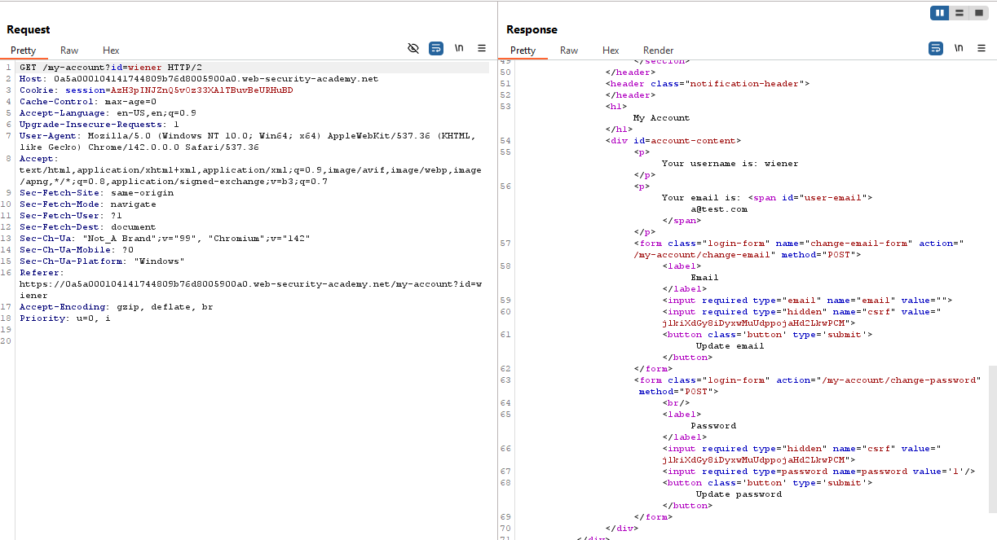
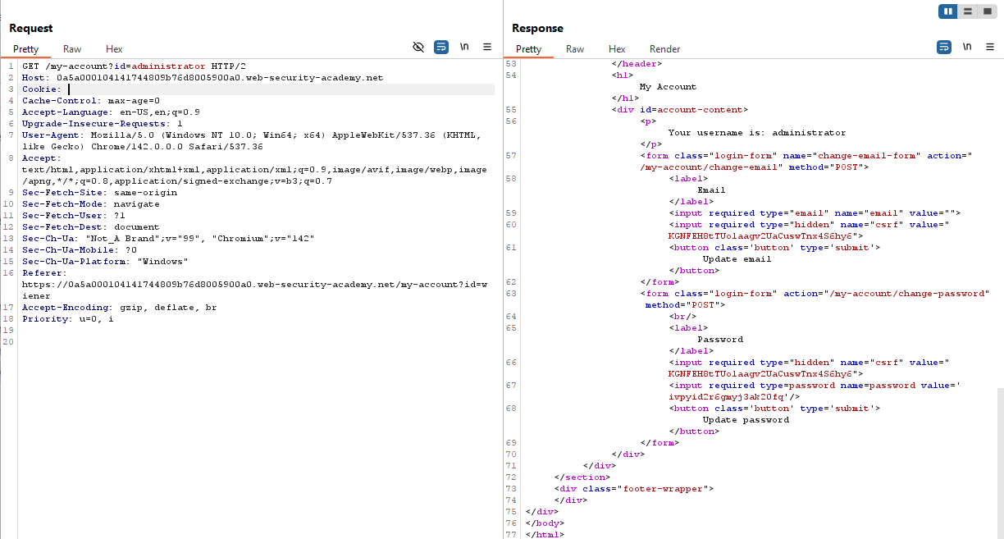

Insecure direct object references
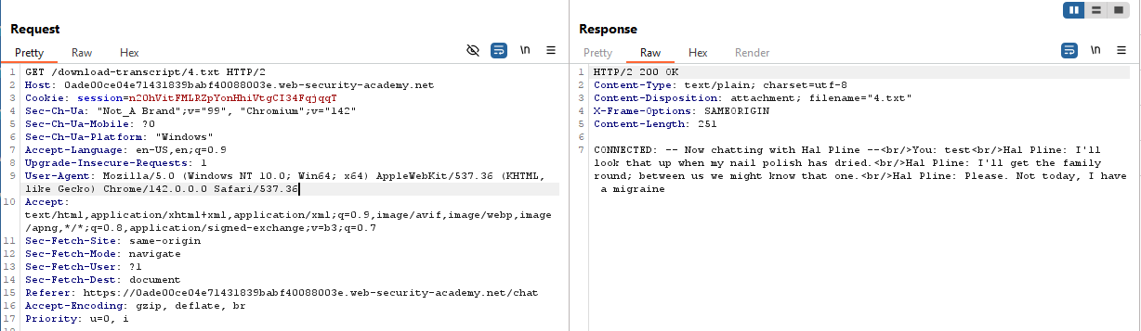
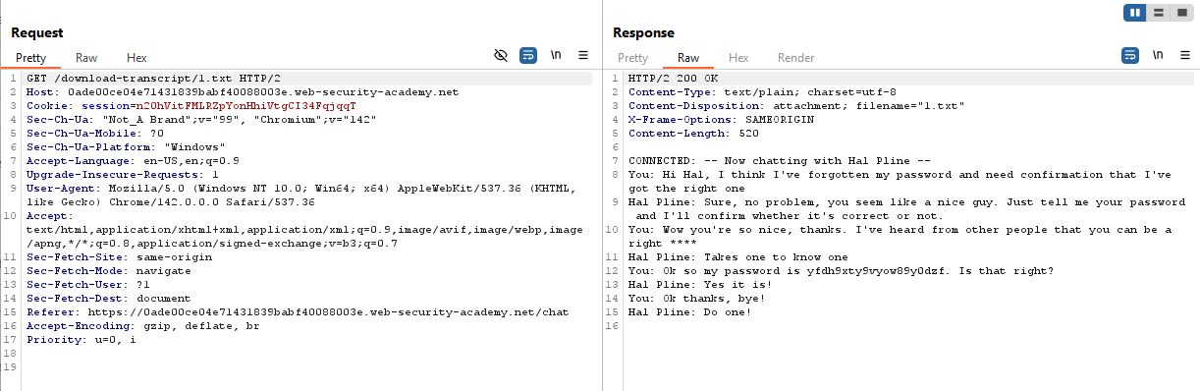

User ID controlled by request parameter with password disclosure
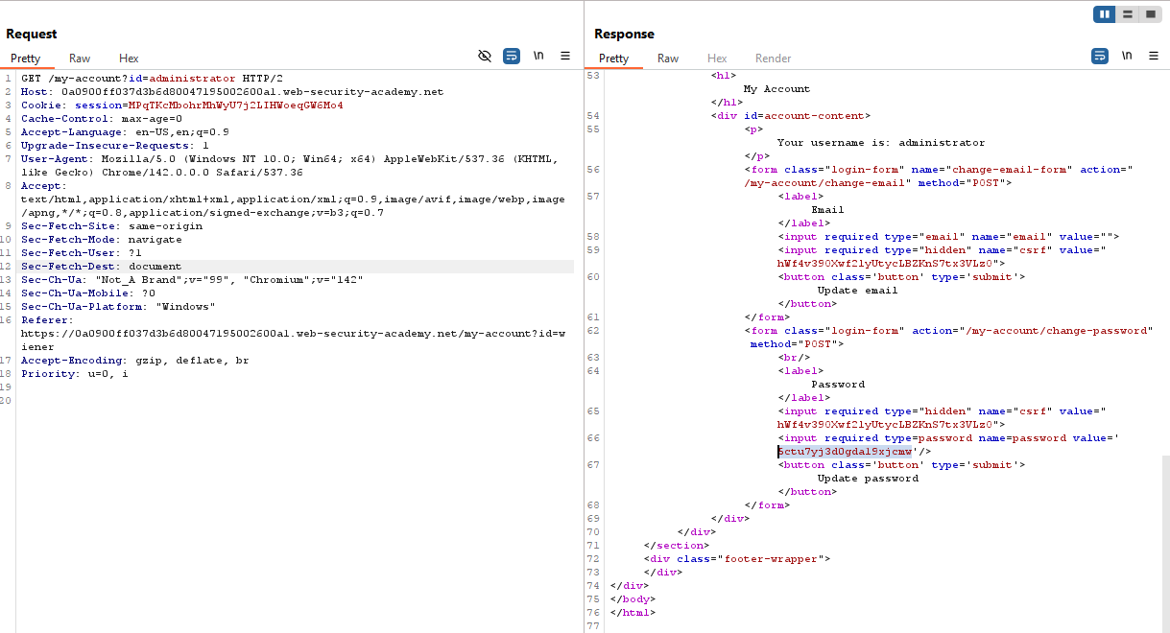

Multi-step process with no access control on one step
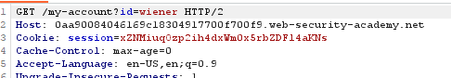
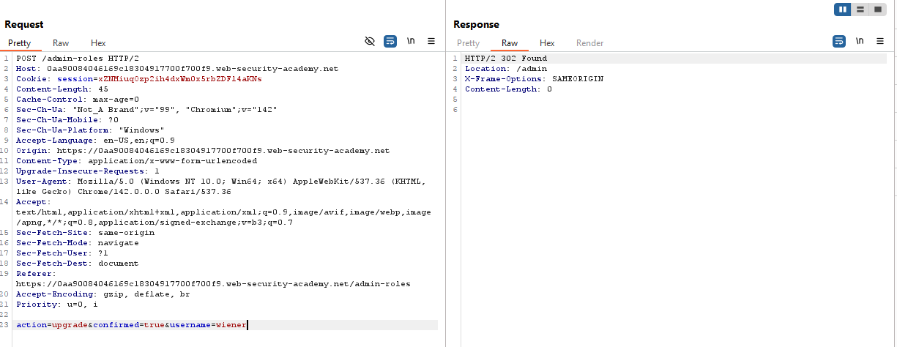
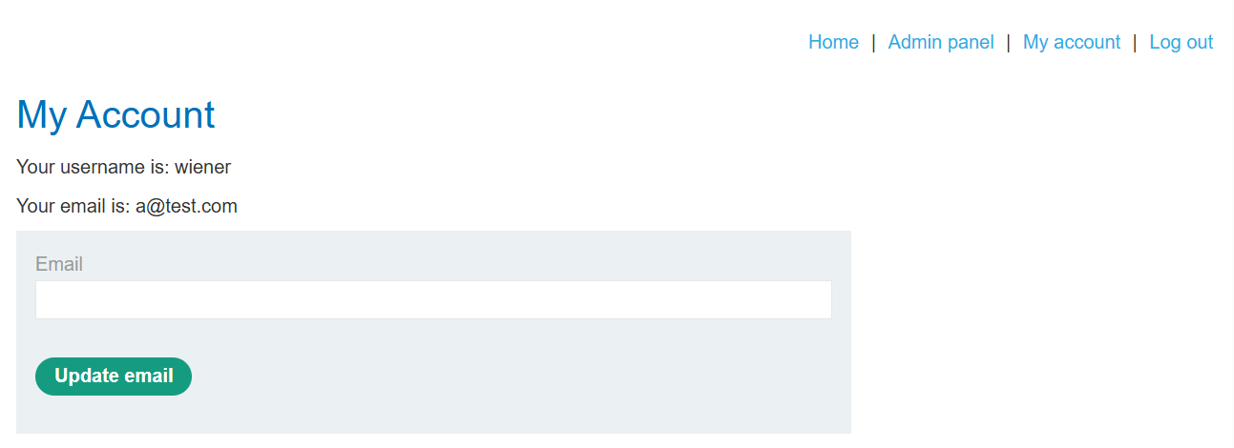

Referer-based access control
